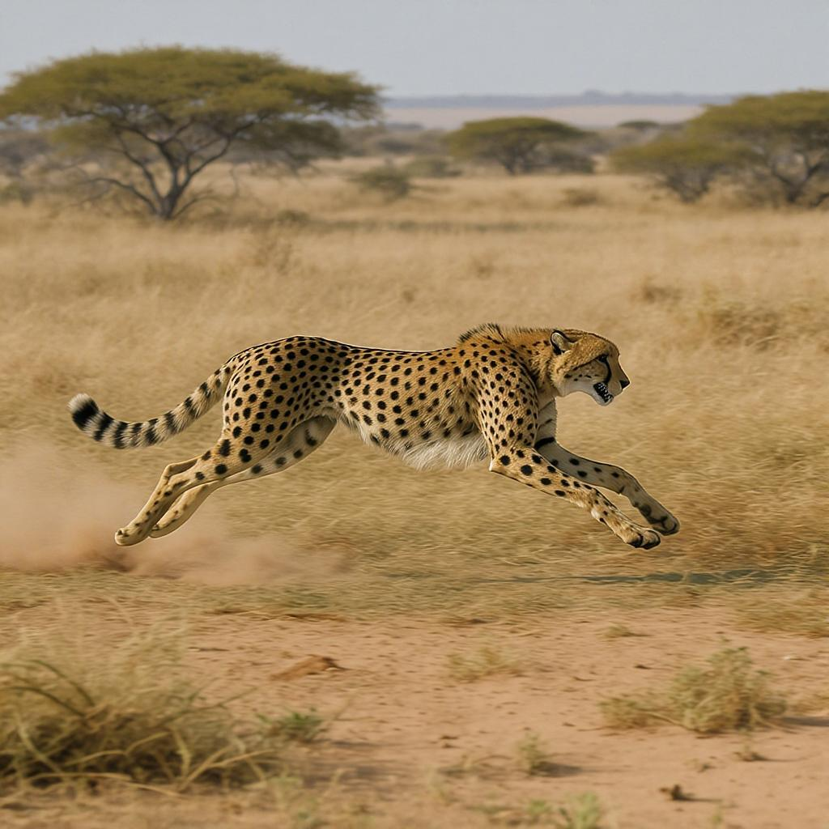

A cheetah running at full speed across the African grasslands, chasing after its prey.

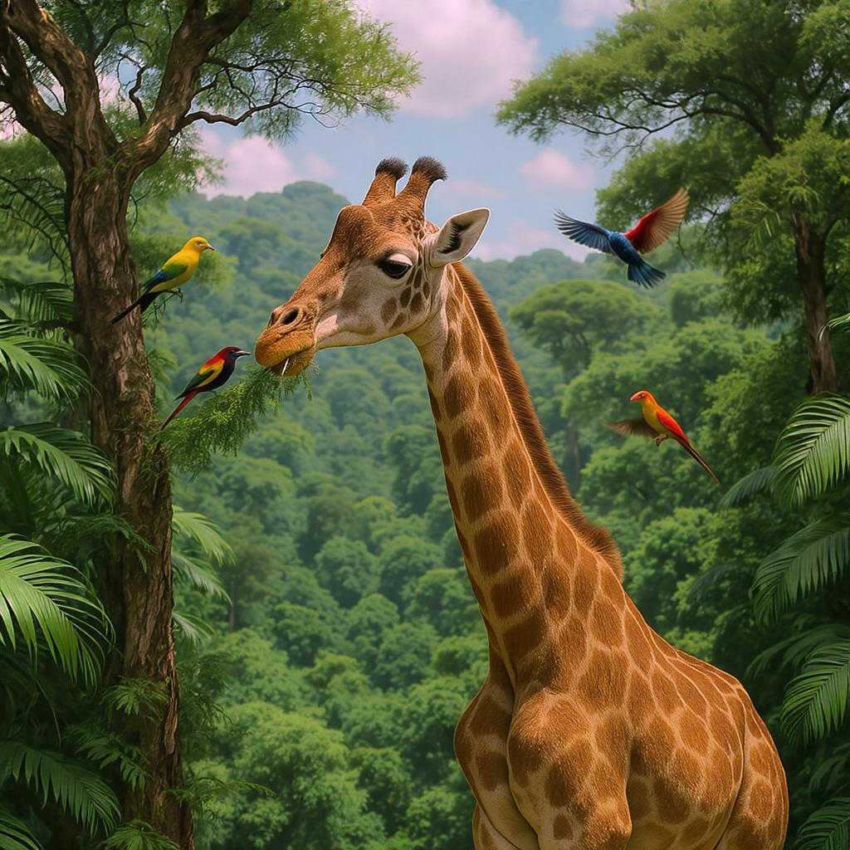

1.

____________________________________________________________________________

A giraffe munching on trees in a lush African jungle with colorful birds flying around."

2.

____________________________________________________________________________

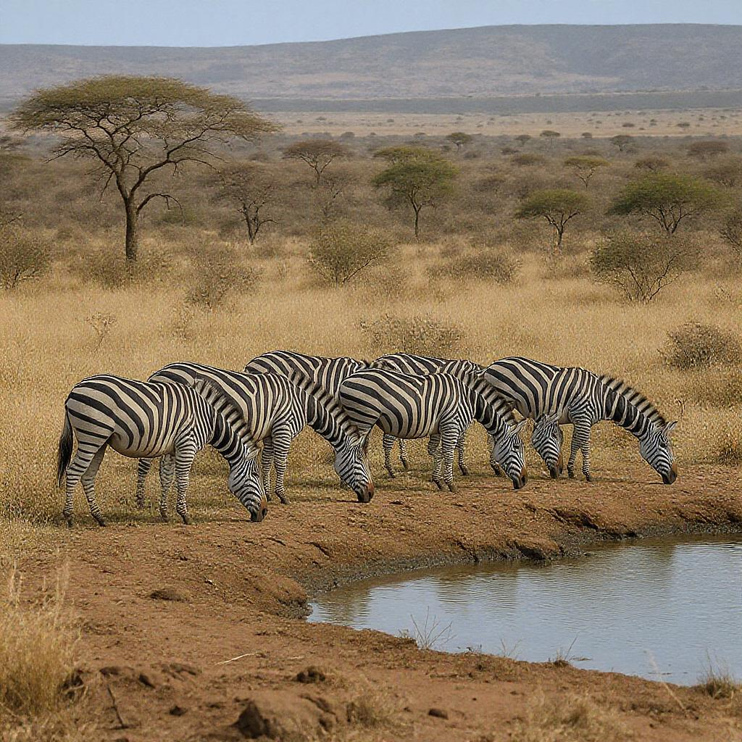

A zebra herd grazing peacefully near a watering hole in the African savannah.

3.

____________________________________________________________________________